**HOTEL MANAGEMENT DATABASE SYSTEM**

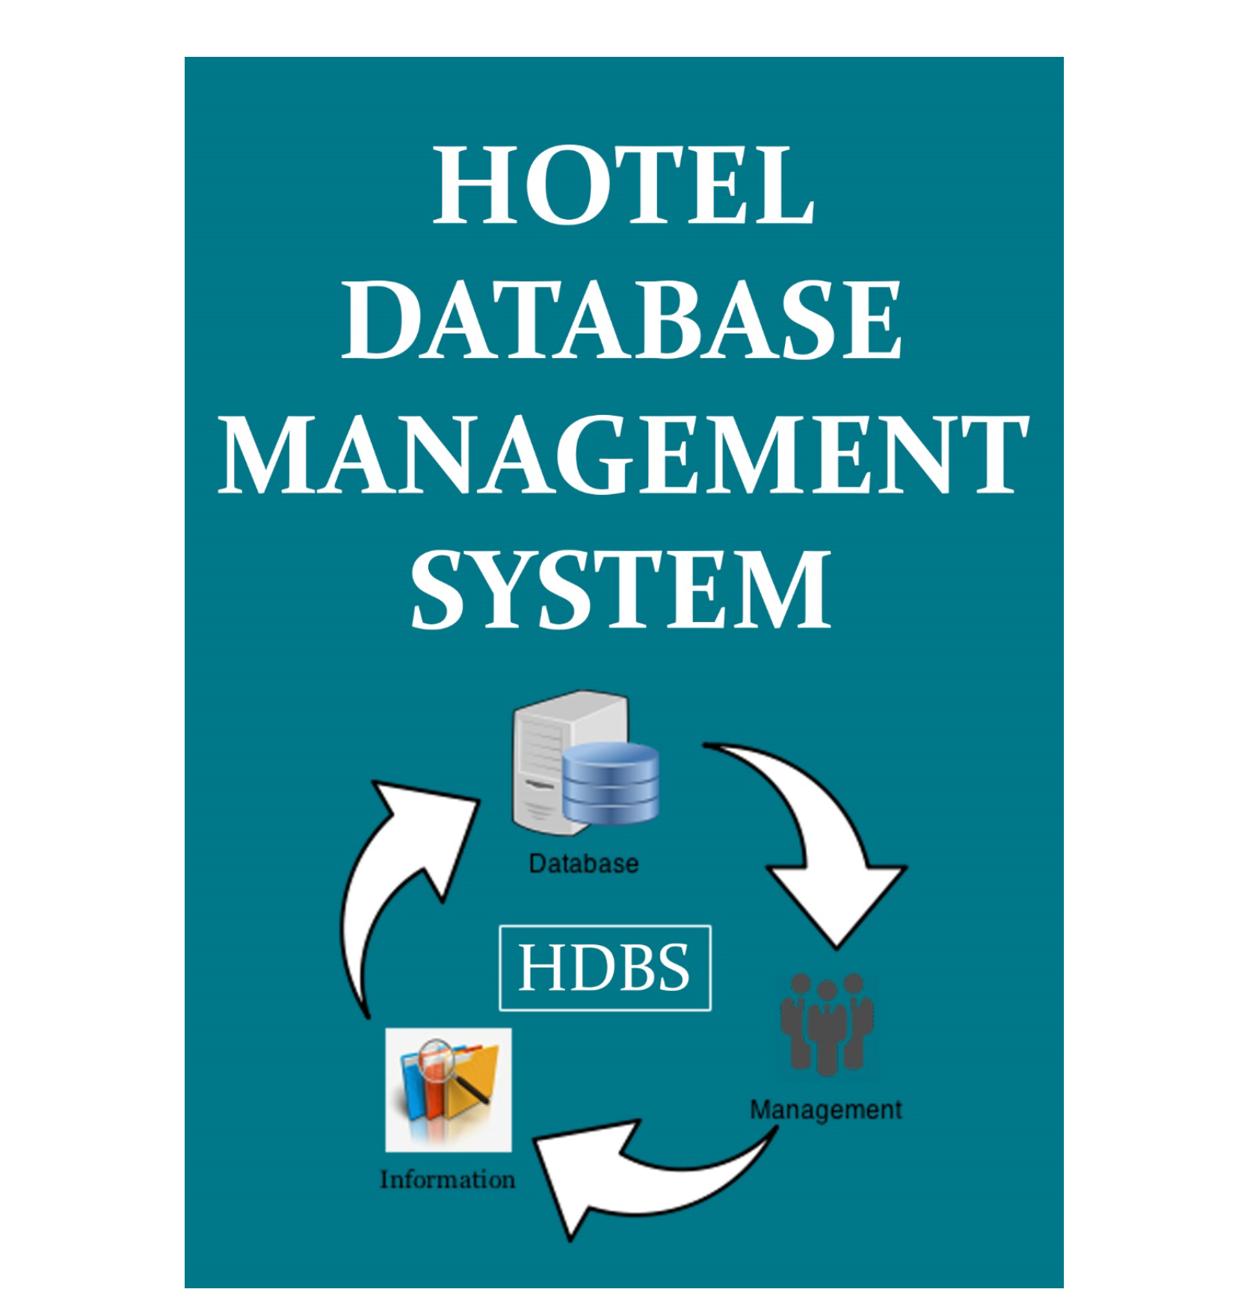

**TABLE OF CONTENTS**

INTRODUCTION

ERR DIAGRAM

TABLES AND RELATIONSHIPS

NORMALIZATION

QUERIES, VIEWS AND TRIGGERS

CHALLENGES

QUESTIONS

## 1.1 INTRODUCTION

### 1.1.1 Objective

Create a database management system for a hotel. The hotel can have multiple chains.

We need an organized management system, which can easily manage all the operations and the data of the hotel chains and hotels respectively.

The system will be managing the following areas:

1. The hotel chains,their details and other informations like their rooms , descriptions and discounts
2. Information about employees and departments
3. Information about guests
4. Management of bookings and other services used by guests

## 

## 1.2 ERR DIAGRAM

I started with designing the structure of the database. I drew the ERR diagram on paper, noting down all the necessary tables. Each table contains columns and their attributes respectively and trying to make an idea about the relationships between tables. I ensured the tables are in a form where I can reduce the data redundancy and make it an easy and simple way.

## 

## 

## 

## 

## 

## 1.3 TABLES AND RELATIONSHIPS

## Bookings

The table contains the data about the bookings made for rooms.

Primary key

1. booking_id

Foreign keys

1. hotel_hotel_id which has many-to-one relationship with the hotel table
2. guests_guest_id which has many-to-one relationship with the hotel table
3. employees_emp_id which has many-to-one relationship with the employees table

## Hotel_services_used_by_guests

Table contains info about the services used by the guests.

Primary key

Service_used_id

Foreign keys

Hotel_services_service_id - Relates to the hotel_services table

Bookings_booking_id - Relates to the booking table

## Department

Contains the data about the different departments of the hotel.

Primary Key

Department_id - Creates a one-to-one relationship with the employees table

## Employees

Data related to the employees.

Primary key

1. Employee_id

Foreign keys

1. Service_id - Denotes many-to-one relations with the department table
2. addresses _id - Denotes one-to-one relationship with the addresses table

Hotel_id - Denotes many-to-one relationship with the hotel table

## Addresses

Defines the information about the address of guests, hotels, hotel chains, employees.

Primary Key

Address_id - Maintains one-to-one relationship with tables, hotel_chain, hotel, employees and guests

## Guests

Has the data about the guests that check in to the hotel.

Primary key

1. guest_id

Foreign_key

1. Address_id that has one-to-one relationship with the address table

## Rooms_booked

Primary Key

1. rooms_booked_id

Foreign keys

1. Booking_id which has one-to-many relationship with the bookings table
2. Room_id which has one-to-many relationship with the rooms table

## 

## 

## 1.4 NORMALIZATION

Database normalization is the process of restructuring a relational database in accordance with a series of so-called normal forms in order to reduce data redundancy and improve data integrity. If a database is normalized until the third normal form then it is considered to be normalized. I tried to normalize the database until third normal form

## 1.6 QUERIES, VIEWS AND TRIGGERS

This was the easiest part for me. As I put a lot of effort in designing the database and creating relationships in a manner that, it will be easier to fetch the data from two or more tables. I wrote the queries as per the requirements. I created two views and triggers

VIEWS

GuestDetails

This view shows all the information about the guests

EmployeeDetails

This view shows all the information about the employees and their respective departments

TRIGGERS

BookingAudit_OnInsert

When a new booking is generated, this trigger will create a booking audit table and insert the data into it

BookingAudit_OnDelete

When a booking is deleted, this trigger will be called and a row will be inserted on the Booking Audit table with the information of the booking that is being deleted

## 1.7 CHALLENGES

1. Creating relationships among tables
2. Making sure all the relationships created among tables are logical and follow the normalization rules
3. Creating the booking and the rooms table and its relationships with other respective tables

## QUESTIONS